Instructions for Authors Submitting Papers to Nordic workshop “Concrete in Arctic Conditions”.

Guzel Shamsutdinova
M.Sc., Ph.D. candidate,
Norwegian University of Science and Technology
Richard Birkelands vei 1a, NO-7034 Trondheim
e-mail: guzel.shamsutdinova@ntnu.no
Stefan Jacobsen
M.Sc., Ph.D., professor
Norwegian University of Science and Technology,
Richard Birkelands vei 1a, NO-7034 Trondheim
e-mail: stefan.jacobsen@ntnu.no

Etc. | Add rows as adequate. Cell boundaries in the table will be made invisible prior to publishing.  The table lines will be removed by the editor

ABSTRACT
The manuscript shall commence with a short abstract and at least four key words. The abstract should summarize the problem, research method and important results. It should be limited to 100 words.

Key words: Concrete, ice, frost resistance, experiment, modelling.

1. INTRODUCTION

1.1 General
These instructions are written according to the rules for authors submitting papers to Nordic mini-seminar “Concrete in Arctic Conditions”; hence, the downloaded document (word version) may be used as a template for writing.

The manuscript is to be written in English (British English).

The manuscript must be handed in in Word format. The present file can be used as a template. The manuscript shall be limited to four (4) pages including illustrations and the reference list. Please, submit your manuscript by sending it to guzel.shamsutdinova@ntnu.no and andrei.shpak@ntnu.no.

1.2 Paper title, author presentation, abstract, and key words
The paper title should be of type size 14 and limited to two lines. Below the headline, there should be a photograph(s) of the author(s) and a short presentation of the author(s). The photograph should be about 40x50 mm and ranged left. If there are more than one author, the photographs should be arranged in a vertical row. The presentation of the author should include the following data: title, name, degree (if any); e-mail address; affiliation; address. If there are any co-authors, they should be presented straight below the first presentation. An abstract and key words should be ranged below the author presentations. The spacing between paper title and photograph and author presentation should be one line. The spacing between author presentation and abstract should be two lines. The author presentation(s), abstract, and key words should be indented 50 mm from the left margin.

2. PREPARATION OF THE TEXT

To give all the papers in the symposium proceedings a uniform layout, the rules of style stated below must be followed.

2.1 Paper size

Use standard DIN A4 paper size (210x297 mm). Adjust the margins as follows:

• Top margin: 30 mm

• Bottom, left and right margins: 23 mm

All text, figures, and tables must fit within the margins.

2.2 Font & font size, spacing, and alignment

Font and font size
The font is Times New Roman. The font size is generally 12 pt. The only exception is the paper title, which is font size 14 pt.

Spacing
The text is single spaced. Paragraphs shall be separated by a blank line. There must be a blank line above all headings and subheadings.

Alignment
The paper title as well as headings and subheadings are aligned to the left. Bulk text is aligned both to the left and to the right.

2.3 Headings and subheadings
Headings and subheadings shall be limited to three levels.

- The first level of headings (major headings) are typed as BOLD UPPERCASE LETTERS.
- The second level of headings (subheadings) are typed in bold lower case letters.
- The third level of headings are typed in italic lower case letters (see example in section 2.2).

Only the first and the second level of headings are numbered. Use TAB between the number and the text in the heading, so the text starts 1.0 cm from the left margin

2.4 Pagination
Page number shall be placed in the middle of the top margin, beginning with page 1 in each manuscript. The pages will be repaginated in the printing.
2.5 Nomenclature
The nomenclature used in relevant European standards as Eurocodes, EN 206-1 and EN 13670 shall be used as far as possible. Only SI-units are allowed. All symbols and abbreviations shall be explained the first time they appear in the text.

3 SPECIAL ELEMENTS

3.1 Equations
Equations should be indented 10 mm from the left margin. They should be numbered consecutively with a number in brackets indented 10 mm from the right according to the following example:
(1)
Please, note, that all variables should be written in italics and that this is valid for symbols both in equations and in the text. Mathematical operators and numbers, e.g., sin, cos, sinh, lg, ln, exp, e, π and indices should not be written in italics (if the index itself is not a variable).

3.2 Figures
The publication will be printed in halftone black/white layout. Please have this in mind, when preparing the figures; if you include a colour figure in your manuscript (e.g. a photo or a graph), then make sure it is also illustrative, when it appears in black/white.

Figures are numbered consecutively throughout the text, starting with 1. Figures are aligned to the left. The figure caption is placed below the figure (text in italic), see example in Fig. 1.

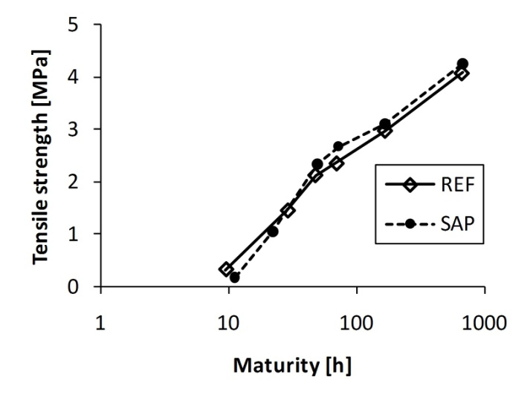 | 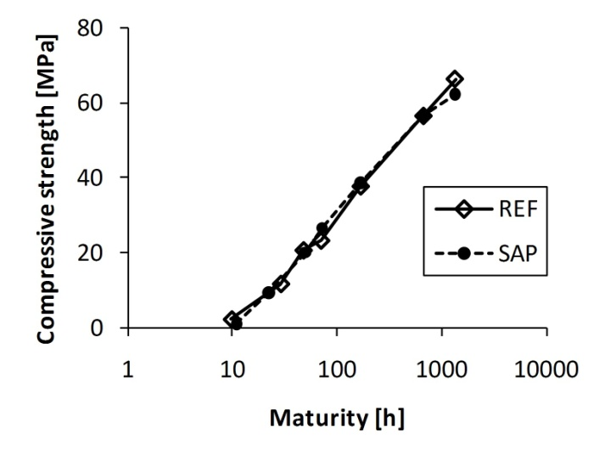
Figure 1 – Strength development. Left: tensile strength. Right: compressive strength.

3.3 Tables
Tables are numbered consecutively throughout the text, starting with 1. Tables are aligned to the left. The figure caption is placed above the table (text in italic), see example in Tab. 1. Tables shall be prepared directly in the document, not inserted as pictures.

Table 1 – Properties of the fresh concrete.
 | Slump | Air content | Bleeding | Hardening
 | EN 12350-2 | EN 12350-7 | DS 423.18 | DS 423.17
 | [mm] | [%] | [vol. %] | [h]
REF | 120-150 | 4.5-4.8 | 0.0 | 4.44
SAP | 130-160 | 1.4-1.7 | 0.1 | 7.12

4. REFERENCES

The references should be numbered consecutively in order of appearance. The number should be written in brackets, e.g., [1]. The references shall be listed at the end of the paper under the major heading REFERENCES, see below.

5 SUBMITTING OF ARTICLES

Please, submit your manuscript by sending it to guzel.shamsutdinova@ntnu.no and andrei.shpak@ntnu.no.

REFERENCES

- Silfwerbrand J: “Improving Concrete Bond in Repaired Bridge Decks,” Concrete International, Vol. 12, No. 9, September 1990, pp. 61-66.
- Silfwerbrand J & Petersson Ö: “Thin Concrete Inlays on Old Concrete Roads,” Proceedings, 5th International Conference on Concrete Pavement Design & Rehabilitation, Purdue University, West Lafayette, Indiana, USA, April 1993, Vol. 2, pp. 255-260.
- Swedish National Road Administration: “Regulations for Bridges,” Part 7, “Bridge Maintenance,” Borlänge, Sweden, 1994, 47 pp. (In Swedish).
- Zhu Y: “Evaluation of Bond Strength between New and Old Concrete by Means of Fracture Mechanics Method,” Bulletin No. 157, Dept. of Structural Mechanics and Engineering, KTH Royal Institute of Technology, Stockholm, 1991, 102 pp.
- Bager D H, Geiker M R, Jensen R M: “Rheology of Self-Compacting Mortars, Influence of Particle Packing,” Nordic Concrete Research, no. 26, 2001, pp. 1-16

