Instructions for authors submitting extended abstracts of presentations to
Nordic mini-seminar: Design and construction of sustainable concrete structures: causes, calculation and consequences of cracks, Oslo 2019.

Reignard Tan
M.Sc., PhD
Norwegian University of Science and Technology, Department of Structural Engineering, N-7491 Trondheim
Multiconsult AS, Oslo, Norway
e-mail: reignard.tan@multiconsult.no

Morten Engen
M.Sc., PhD, Adjunct Associate Professor
Norwegian University of Science and Technology, Department of Structural Engineering, N-7491 Trondheim
Multiconsult AS, Oslo, Norway
e-mail: morten.engen@multiconsult.no

The table lines will be removed by the editor!

ABSTRACT
The manuscript shall commence with a short abstract and some key words. The abstract ought to summarise problem, research method, and important results. It ought to be limited to 50-100 words.

Key words: Cracking, large concrete structures, crack width calculation methods, modelling uncertainty of crack width calculations, tension stiffening, consequences of cracking.

1. INTRODUCTION

1.1 General
These instructions are the paper guidelines to writing the extended abstracts of the presentations for the Nordic mini-seminar: Design and construction of sustainable concrete structures: causes, calculation and consequences of cracks, Oslo 2019. By following the guidelines, you as author ensure that you present the paper of your extended abstract in a clear and attractive way for the seminar proceedings.

The manuscript is to be written in English.

The manuscript must be handed in Word format. The present file should be used as a template. The manuscript shall be limited to two (2) pages including illustrations and the reference list.

1.2 Paper title, author presentation, abstract, and key words
The paper title shall be in the top of the paper. Below the headline, there shall be a photograph(s) of the author(s) and a short presentation of the author(s). The photograph shall be approx. 40×50 mm and aligned to the left. If there is more than one author, the photographs shall be arranged in a vertical column. The presentation of the author(s) shall include: Name, degree (if any); title, affiliation, and e-mail address.
The abstract and key words are placed below the author presentation(s). The spacing between paper title and photograph/author presentation shall be one line. The spacing between author presentation and abstract as well as the spacing between abstract and key words shall also be one line.

2 PREPARATION OF THE TEXT
To give all the papers in the seminar proceedings a uniform layout, the rules of style stated below must be followed.

2.1 Paper size
Use standard DIN A4 paper size (210×297 mm). Adjust the margins as follows:

- Top margin: 30 mm
- Bottom, left and right margins: 23 mm

All text, figures, and tables must fit within the margins.

2.2 Font & font size, spacing, and alignment
Font and font size
The font is Times New Roman. The font size is generally 12 pt. The only exception is the paper title, which is font size 14 pt.

Spacing
The text is single spaced. Paragraphs shall be separated by a blank line.

Alignment
The paper title as well as headings and subheadings are aligned to the left. Bulk text is aligned both to the left and to the right.

2.3 Headings and subheadings
Headings and subheadings shall be limited to three levels.

- The first level of headings (major headings) are typed as BOLD UPPERCASE LETTERS.
- The second level of headings (subheadings) are typed in bold lower case letters.
- The third level of headings are typed in italic lower case letters (see example in section 2.2).

Only the first and the second level of headings are numbered. Use TAB between the number and the text in the heading, so the text starts 1.0 cm from the left margin

2.4 Pagination
Page number shall be placed in the middle of the top margin, beginning with page 1 in each manuscript. The pages will be repaginated in the printing.

2.5 Nomenclature
The nomenclature used in relevant European standards as Eurocodes, EN 206-1 and EN 13670 shall be used as far as possible. Only SI-units should be used. All symbols and abbreviations shall be explained the first time they appear in the text.

3 SPECIAL ELEMENTS

3.1 Equations
Equations shall be indented 1.0 cm from the left margin. They shall be numbered consecutively with a number in brackets:

(1)

3.2 Figures
Figures are numbered consecutively throughout the text, starting with 1. Figures are aligned to the left. The figure caption is placed below the figure (text in italic), see example in Fig. 1.

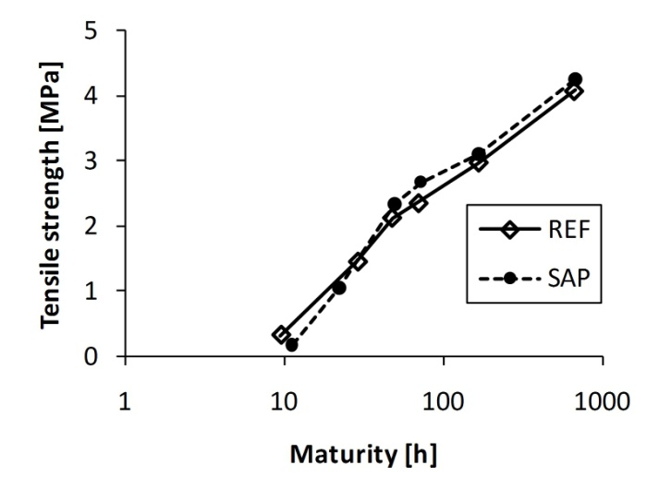 | 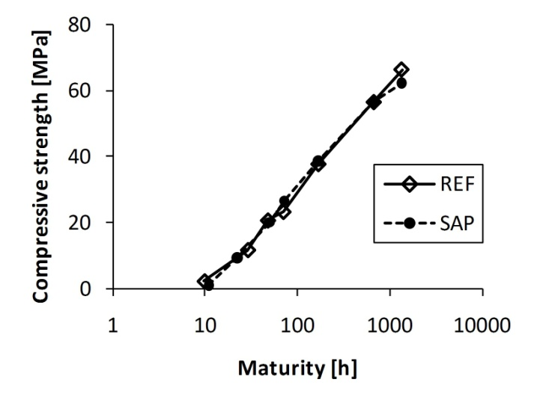
Figure 1 – Strength development. Left: tensile strength. Right: compressive strength.

3.3 Tables
Tables are numbered consecutively throughout the text, starting with 1. Tables are aligned to the left. The figure caption is placed above the table (text in italic), see example in Tab. 1.

Table 1 – Properties of the fresh concrete.
 | Slump | Air content | Bleeding | Hardening
 | EN 12350-2 | EN 12350-7 | DS 423.18 | DS 423.17
 | [mm] | [%] | [vol. %] | [h]
REF | 120-150 | 4.5-4.8 | 0.0 | 4.44
SAP | 130-160 | 1.4-1.7 | 0.1 | 7.12

3.4 References
In the text, references to literature are made in square brackets [xx], where xx refers to the relevant number in the reference list.

4 SOME DOS AND DON’TS
Please obey to the following:

- Use the computer’s spell check to avoid spelling errors.
- Do not use automatic numbering of paragraphs, tables, figures and references.
- Do not use automatic cross references and footnotes.
- Do not use indents at the beginning of paragraphs.
- Avoid inappropriate commercialism.

When you have prepared your manuscript, please submit it by sending it to reignard.tan@multiconsult.no

REFERENCES

[1] Tan, R., Hendriks, M.A.N., and Kanstad, T.: “Evaluation of current crack width calculation methods according to Eurocode 2 and fib Model Code 2010”, fib Symposium in Maastricht, (2017).
[2] DS/CEN/TS 12390-9:2006: “Testing hardened concrete - Part 9: Freeze-thaw resistance – Scaling”, The Danish Standards Association (2006)
[3] Silfwerbrand, J., Petersson, Ö.: “Thin concrete inlays on old concrete roads”, Proceedings, 5th International Conference on Concrete Pavement Design and Rehabilitation, West Lafayette, Indiana, USA, vol. 2, pp. 255-260 (1993)
[4] Zhu, Y.: “Evaluation of bond strength between new and old concrete by means of fracture mechanics method” , Bulletin No. 157, Dept. of Structural Mechanics and Engineering, Royal Institute of Technology, Stockholm, 102 pp, (1991)

