Instructions for authors submitting papers to
XXIV Concrete Research Symposium, Sandefjord 2020

Marianne Tange Hasholt
M.Sc., Ph.D., associate professor
Technical University of Denmark
Brovej 118, DK-2800 Kgs. Lyngby
e-mail: matah@byg.dtu.dk

Morten Bjerke
M.Sc.
Norsk Betongforening
Postboks 2312 Solli, N-0201 Oslo
e-mail: morten.bjerke@tekna.no

The table lines will be removed by the editor!

ABSTRACT
The manuscript shall commence with a short abstract and at least four key words. The abstract ought to summarise problem, research method, and important results. It ought to be limited to 100 words. In order to distribute the papers in the different sessions, please include one or more of the key words below.

Key words: Additives, Admixtures, Aggregate, Aging, Binders, Cracking, Carbonation, Chlorides, Corrosion, Creep, Execution, Fibres, Frost Action, Knowledge and Teaching, Mix Design, Modelling, Nuclear, Reinforcement, Renovation, Repair, Rheology, SCC, Shrinkage, Structural Design, Surfaces, Sustainability, Testing.

1. INTRODUCTION

1.1 General
These writing instructions are the paper guidelines to XXIV Concrete Research Symposium, Sandefjord 2020. By following the guidelines, you as author ensure that you present your paper in a clear and attractive way.

The manuscript is to be written in English (British English).

The manuscript must be handed in in Word format. The present file can be used as a template. The manuscript shall be limited to four (4) pages including illustrations and the reference list.

1.2 Paper title, author presentation, abstract, and key words
The paper title shall be one or maximum two lines. Below the headline, there shall be a photograph(s) of the author(s) and a short presentation of the author(s). The photograph shall be approx. 40×50 mm and aligned to the left. If there is more than one author, the photographs shall be arranged in a vertical column. The presentation of the author(s) shall include: Name, degree (if any); title, affiliation, address, and e-mail address.

The abstract and key words are placed below the author presentation(s). The spacing between paper title and photograph/author presentation shall be one line. The spacing between author presentation and abstract as well as the spacing between abstract and key words shall also be one line.

2 PREPARATION OF THE TEXT
To give all the papers in the symposium proceedings a uniform layout, the rules of style stated below must be followed.

2.1 Paper size
Use standard DIN A4 paper size (210×297 mm). Adjust the margins as follows:

- Top margin: 30 mm
- Bottom, left and right margins: 23 mm

All text, figures, and tables must fit within the margins.

Please pay attention to font size of illustrations if using copy/paste.

2.2 Font & font size, spacing, and alignment

Font and font size
The font is Times New Roman. The font size is generally 12 pt. The only exception is the paper title, which is font size 14 pt.

Spacing
The text is single spaced. Paragraphs shall be separated by a blank line. There must be a blank line above all headings and subheadings.

Alignment
The paper title as well as headings and subheadings are aligned to the left. Bulk text is aligned both to the left and to the right.

2.3 Headings and subheadings
Headings and subheadings shall be limited to three levels.

- The first level of headings (major headings) are typed as BOLD UPPERCASE LETTERS.
- The second level of headings (subheadings) are typed in bold lower case letters.
- The third level of headings are typed in italic lower case letters (see example in section 2.2).

Only the first and the second level of headings are numbered. Use TAB between the number and the text in the heading, so the text starts 1.0 cm from the left margin

2.4 Pagination
Page number shall be placed in the middle of the top margin, beginning with page 1 in each manuscript. The pages will be repaginated in the processing.

2.5 Nomenclature
The nomenclature used in relevant European standards as Eurocodes, EN 206-1 and EN 13670 shall be used as far as possible. Only SI-units are allowed. All symbols and abbreviations shall be explained the first time they appear in the text.

3 SPECIAL ELEMENTS

3.1 Equations
Equations shall be indented 1.0 cm from the left margin. They shall be numbered consecutively with a number in brackets indented 1.0 cm from the right according to the following example:

(1)

3.2 Figures
The publication will not be printed but communicated by digital means, allowing the use of colour palettes.

Figures are numbered consecutively throughout the text, starting with 1. Figures are aligned to the left. The figure caption is placed below the figure (text in italic), see example in Fig. 1.

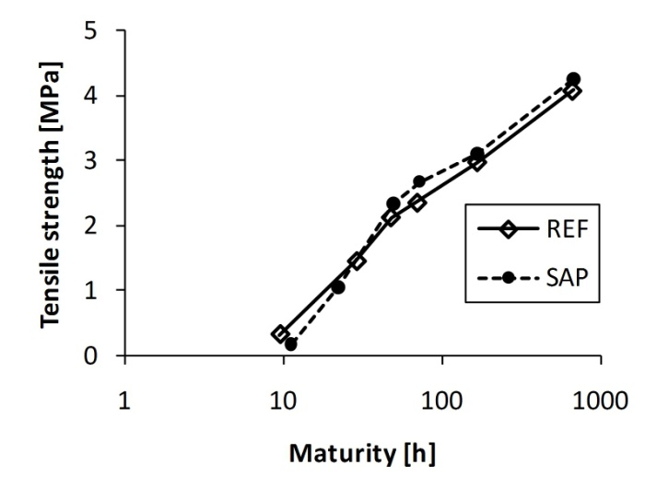 | 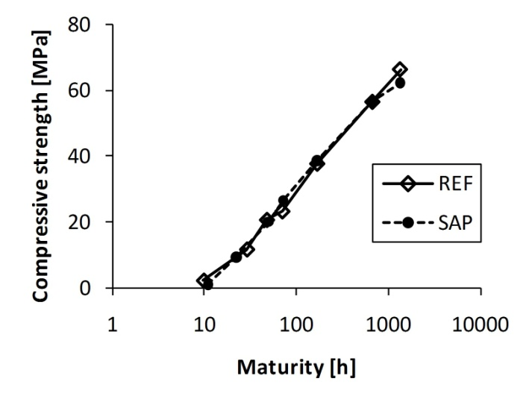
Figure 1 – Strength development. Left: tensile strength. Right: compressive strength.

3.3 Tables
Tables are numbered consecutively throughout the text, starting with 1. Tables are aligned to the left. The figure caption is placed above the table (text in italic), see example in Tab. 1. Tables shall be prepared directly in the document, not inserted as pictures.

Table 1 – Properties of the fresh concrete.
 | Slump | Air content | Bleeding | Hardening
 | EN 12350-2 | EN 12350-7 | DS 423.18 | DS 423.17
 | [mm] | [%] | [vol. %] | [h]
REF | 120-150 | 4.5-4.8 | 0.0 | 4.44
SAP | 130-160 | 1.4-1.7 | 0.1 | 7.12

3.4 References
In the text, references to literature are made in square brackets [xx], where xx refers to the relevant number in the reference list.

4 SOME DOS AND DON’TS
Please obey to the following:

- Use the computer’s spell check to avoid spelling errors.
- Do not use automatic numbering of paragraphs, tables, figures and references.
- Do not use automatic cross references and footnotes.
- Do not use indents at the beginning of paragraphs.
- Avoid inappropriate commercialism.

REFERENCES

[1] Bager, D.H., Geiker, M.R., Jensen, R.M.: “Rheology of self-compacting mortars, influence of particle packing”, Nordic Concrete Research no. 26, pp. 1-16 (2001)
[2] DS/CEN/TS 12390-9:2006: “Testing hardened concrete - Part 9: Freeze-thaw resistance – Scaling”, The Danish Standards Association (2006)
[3] Silfwerbrand, J., Petersson, Ö.: “Thin concrete inlays on old concrete roads”, Proceedings, 5th International Conference on Concrete Pavement Design and Rehabilitation, West Lafayette, Indiana, USA, vol. 2, pp. 255-260 (1993)
[4] Zhu, Y.: “Evaluation of bond strength between new and old concrete by means of fracture mechanics method” , Bulletin No. 157, Dept. of Structural Mechanics and Engineering, Royal Institute of Technology, Stockholm, 102 pp, (1991)

